**HER2 Project – Circle of Giving Grant**

Samuel Tsang, Aurora Blucher, Nate Evans

ASB Methods Log

Updated 07/02/21

**A1 Prioritizing HER2 mutations in Breast Cancer**

Mutation data for 6,664 breast cancer patient samples were downloaded from cBioPortal (1,2) across a total of 13 breast cancer studies (3–15). At the time of download, the public cBioPortal used the hg19/GRCh37 version of the reference genome. Mutations in cBioPortal are assumed to be on the (+) strand unless otherwise noted by dataset depositors. Note for data set citation, using Pan Cancer TCGA (cited hoadley and berger), waiting to hear about citation for the Metastatic Breast Cancer Project (early data available through cBioPortal.

A total of 97 ERBB2 alterations across 222 samples were collected, including single nucleotide polymorphisms and small insertions and deletions. We required SNPs to be missense or splice-site and included both frame- shift and in-frame alterations. For each alteration, we generated a primer sequence (programmatically in R) to enable primer generation for the mutation screen platform.

**A2 Candidate Resistance Driver Genes in HER2 Breast Cancer**

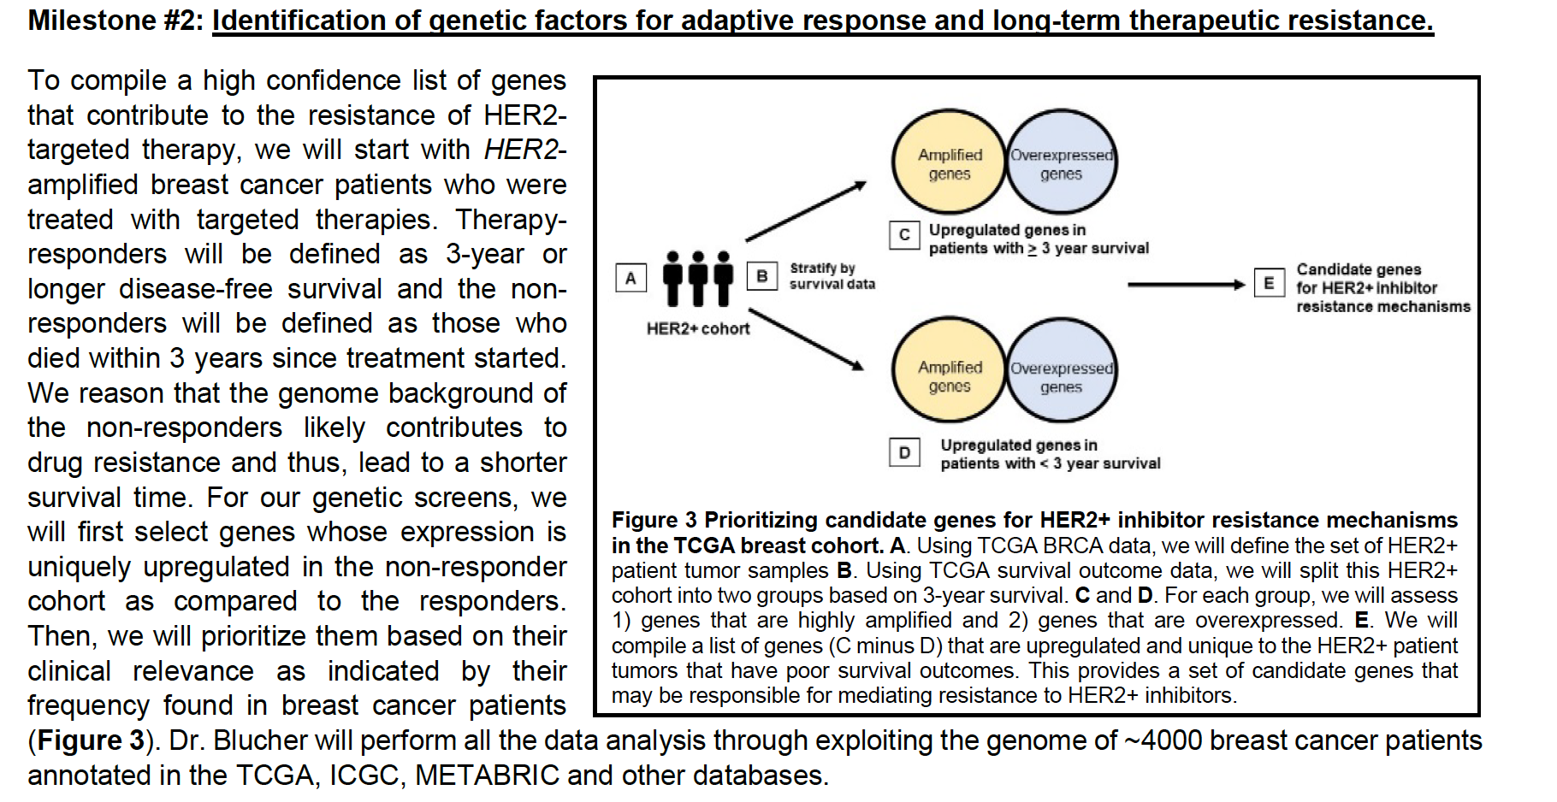

Figure 0. Fm Samuel’s grant application to OHSU Circle of Giving. Aim 2 Overview for

prioritizing candidate resistance drivers in HER2 breast cancers.

-TCGA breast~~, pull all patients with HER2 indicator via IHC~~

Gistic, ERBB2 =2, amplified; note these may be different thresholds (n=133 total)

*can check against PAM50 if time / check against IHC* if time

-pull survival data, plot distribution, break into <3 years versus >=3 years or similar; see if there is a break

Samples >3 years, 54 total

Samples<=3, 79 total



**Figure 1.** Histogram of survival time for TCGA BRCA HER2 positive patients. Blue dash lined indicates 3 years (1095 days).

-identify top copy number features DE between two groups

Counted number of (GISTIC==2) and compared between 2 groups with proportions test

Removed any genes with <5 samples in the Short group

Note, prioritized list does not have any CN genes passing FDR<0.20

-identify top genes DE between two groups

Using TCGAbiolinks package/ for querying RNASeq RSEEM (expected counts)

Run DE through the package, see notes in R script:

*HER2_Aim2_CandidateResistanceDrivers.Rmd*

~~Prioritized list of 103 genes with negative fold change (i.e. overexpressed in Short group)~~

~~Run list against Samuel’s library; 83 found in library, 20 to make~~ Updated 07/02/21

Prioritized list of 135 genes that are up-regulated in the Short survival

Of these, 104 are under FDR< 0.20, but list is extended out to FDR <0.50 as Samuel has room for ~100 genes on his screening panel.

See workbook *Table_ShortVsLong_UppQuantNorm_DE_FoldChange_FDR_ShortHits_LibraryAnnotation_210625.xlsx*

Of these, 111/135 are annotated in Samuel’s existing clone library. List to Samuel 06/25/21 for Aim 2 drug screen work, he will pull clones from library and assess how many need to be made for the rest of the screen. In total, he has capacity to screen about ~100 genes.



**Figure 2.** Volcano plot showing differentially expressed genes between two groups of HER2 breast cancer patients in TCGA (TCGA BRCA). Blue indicates genes are over-expressed in the ‘Short survival’ cohort, with reported survival <=3 years.

**References**

1. Cerami E, Gao J, Dogrusoz U, Gross BE, Sumer SO, Aksoy BA, et al. The cBio Cancer Genomics Portal: An Open Platform for Exploring Multidimensional Cancer Genomics Data: Figure 1. Cancer Discov. 2012 May;2(5):401–4.

2. Gao J, Aksoy BA, Dogrusoz U, Dresdner G, Gross B, Sumer SO, et al. Integrative Analysis of Complex Cancer Genomics and Clinical Profiles Using the cBioPortal. Sci Signal. 2013 Apr 2;6(269):pl1–pl1.

3. Razavi P, Chang MT, Xu G, Bandlamudi C, Ross DS, Vasan N, et al. The Genomic Landscape of Endocrine-Resistant Advanced Breast Cancers. Cancer Cell. 2018 Sep;34(3):427-438.e6.

4. Razavi P, Dickler MN, Shah PD, Toy W, Brown DN, Won HH, et al. Alterations in PTEN and ESR1 promote clinical resistance to alpelisib plus aromatase inhibitors. Nat Cancer. 2020 Apr;1(4):382–93.

5. Tan J, Ong CK, Lim WK, Ng CCY, Thike AA, Ng LM, et al. Genomic landscapes of breast fibroepithelial tumors. Nat Genet. 2015 Nov;47(11):1341–5.

6. Martelotto LG, De Filippo MR, Ng CK, Natrajan R, Fuhrmann L, Cyrta J, et al. Genomic landscape of adenoid cystic carcinoma of the breast: Breast adenoid cystic carcinoma genomics. J Pathol. 2015 Oct;237(2):179–89.

7. Pereira B, Chin S-F, Rueda OM, Vollan H-KM, Provenzano E, Bardwell HA, et al. The somatic mutation profiles of 2,433 breast cancers refine their genomic and transcriptomic landscapes. Nat Commun. 2016 Sep 1;7(1):11479.

8. Nixon MJ, Formisano L, Mayer IA, Estrada MV, González-Ericsson PI, Isakoff SJ, et al. PIK3CA and MAP3K1 alterations imply luminal A status and are associated with clinical benefit from pan-PI3K inhibitor buparlisib and letrozole in ER+ metastatic breast cancer. Npj Breast Cancer. 2019 Dec;5(1):31.

9. Kan Z, Ding Y, Kim J, Jung HH, Chung W, Lal S, et al. Multi-omics profiling of younger Asian breast cancers reveals distinctive molecular signatures. Nat Commun. 2018 Dec;9(1):1725.

10. Shah SP, Roth A, Goya R, Oloumi A, Ha G, Zhao Y, et al. The clonal and mutational evolution spectrum of primary triple-negative breast cancers. Nature. 2012 Jun;486(7403):395–9.

11. Banerji S, Cibulskis K, Rangel-Escareno C, Brown KK, Carter SL, Frederick AM, et al. Sequence analysis of mutations and translocations across breast cancer subtypes. Nature. 2012 Jun 21;486(7403):405–9.

12. The Oslo Breast Cancer Consortium (OSBREAC), Stephens PJ, Tarpey PS, Davies H, Van Loo P, Greenman C, et al. The landscape of cancer genes and mutational processes in breast cancer. Nature. 2012 Jun;486(7403):400–4.

13. Hoadley KA, Yau C, Hinoue T, Wolf DM, Lazar AJ, Drill E, et al. Cell-of-Origin Patterns Dominate the Molecular Classification of 10,000 Tumors from 33 Types of Cancer. Cell. 2018 05;173(2):291-304.e6.

14. Berger AC, Korkut A, Kanchi RS, Hegde AM, Lenoir W, Liu W, et al. A Comprehensive Pan-Cancer Molecular Study of Gynecologic and Breast Cancers. Cancer Cell. 2018 Apr;33(4):690-705.e9.

15. Lefebvre C, Bachelot T, Filleron T, Pedrero M, Campone M, Soria J-C, et al. Mutational Profile of Metastatic Breast Cancers: A Retrospective Analysis. Mardis ER, editor. PLOS Med. 2016 Dec 27;13(12):e1002201.